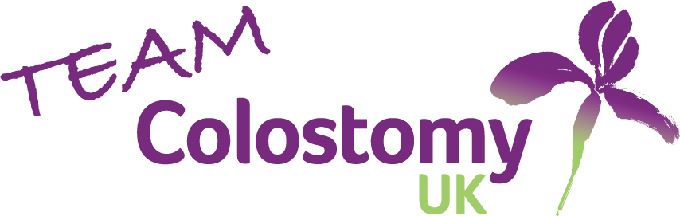
Team Colostomy UK Match Day photographer

About us:
Team Colostomy UK is the Rugby League team of Colostomy UK A registered Charity that exists to make a positive difference for anyone impacted by any kind of stoma or stoma surgery.
We are looking for a volunteer Match Day Photographer to capture the excitement and action of our matches
Purpose:
This role focuses on photographing or PDRL and Wheelchair RL matches, creating a visual record of our teams’ performances while providing engaging content. This is an excellent opportunity for photographers to build their portfolio while contributing to our team and charity.
Responsible to:
Team Manager
Duties and responsibilities:
- Attend all PDRL and Wheelchair RL matches
- Capture high quality action shots during gameplay, showcasing key moments, tries, tackles, and team celebrations.
- Document the atmosphere and spirit of matchdays.
- Edit and select the best images for use
- Provide photos within a timely manner for social media and website use
Desirable skills and characteristics:
- Experience in sports or action photography
- Access to suitable camera equipment capable of capturing fast-paced action
- Basic photo editing skills
- Reliable attendance at scheduled matches
- Understanding of rugby league sufficient to anticipate key moments
- Enthusiasm for the sport and Colostomy UK
Benefits:
- Opportunity to develop sports photography skills and portfolio.
- Gain valuable professional and personal experience in Sports media
- Be a part of an exciting Team that is challenging and changing perceptions of life with a stoma.
- Expenses including mileage and any necessary accommodation costs will be reimbursed.
Time commitment:
All PDRL and Wheelchair Match days (Approximately 10 a year across the UK) plus remote advice and guidance to players when needed.
How to apply?
If you are interested in applying for this role, please contact Giovanni Cinque at Giovanni.cinque@colostomyuk.org

